**Name: Varad Patil**

**Batch: A2**

**Roll no: 120A2036**

**Experiment 12**

**Aim:** SSH-Configuration-on Ubuntu20.04

**Software:** Ubuntu

**Procedure:**

* Open two terminal one for server and other for client.
* Become a super user by sudo su
* **Server Configuration**
* Enter the following command for server terminal

1. Install ssh by command apt-get install openssh-server
2. Then type y
3. Open sshd_config file from etc/ssh by using command cd /etc/ssh
4. Use gedit sshd_config and make command permit Rootlogin yes and change PasswordAuthentication yes (from no).
5. Again cd /home/siesgst
6. Then systemctl restart sshd.service
7. Then get the status of ssh by systemctl status ssh
8. ufw allow ssh

* **Client configuration**
* Enter the following command for server terminal

1. sudo su.
2. Install ssh by command apt-get install openssh-client.
3. systemctl status ssh
4. get ip of the device by command ip a
5. now connect the system to which you want to connect by ip address using

ssh username@ipaddress: ssh [siesgst@10.0.2.15](mailto:siesgst@10.0.2.15).

* Now you can access a file using ssh configuration from any pc in the network.

**Output:**

**SERVER CONFIGURATION:**

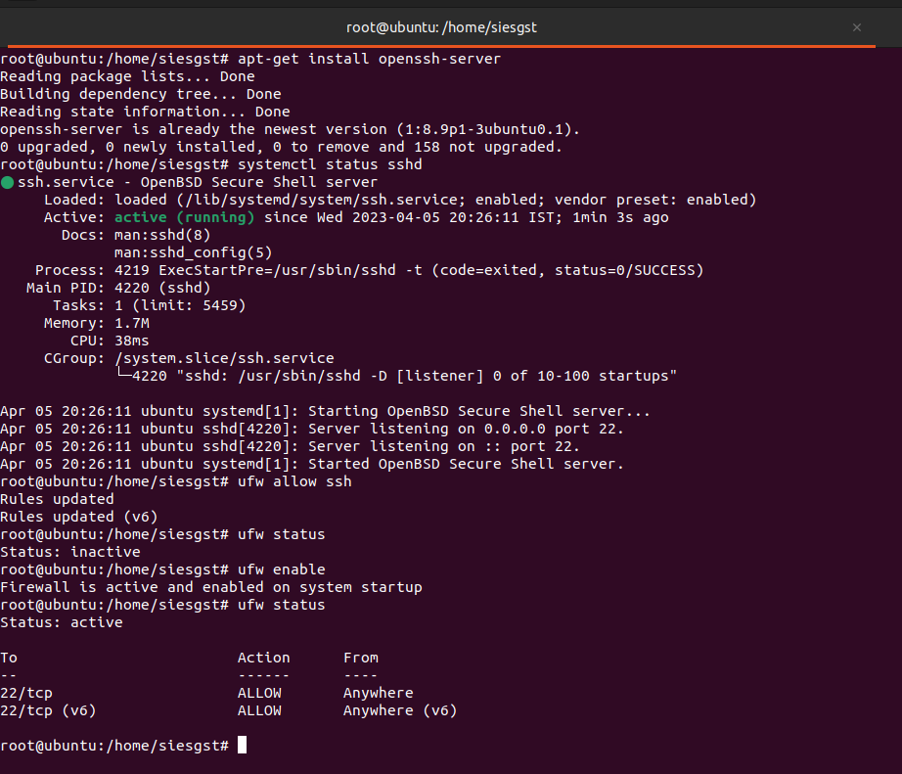

**CLIENT CONFIGURATION:**

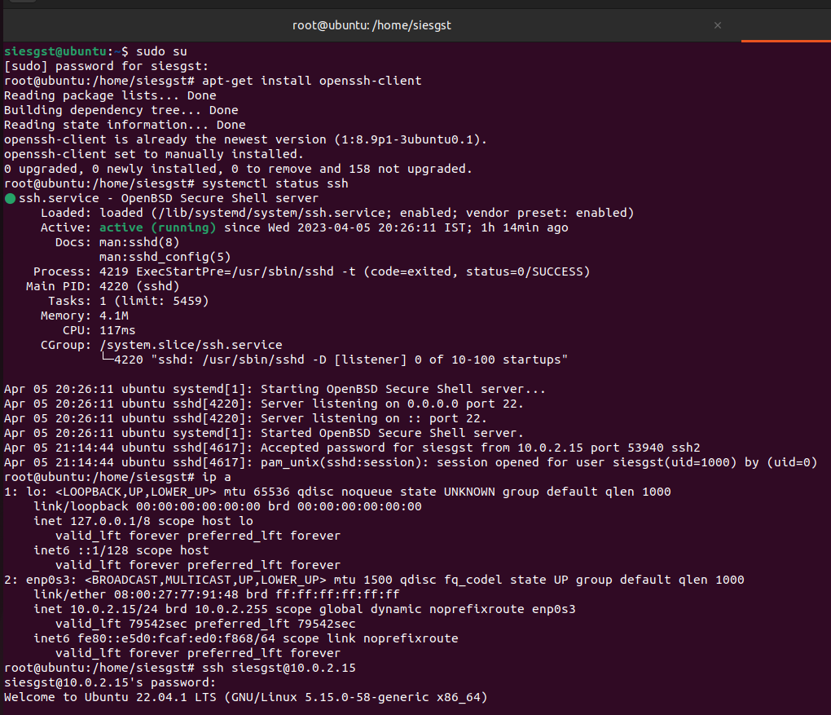

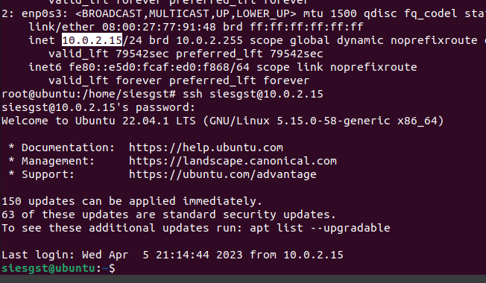

**Conculsion:**

We have successfully performed SSH configuration and accessed a file from remote PC in network using SSH Configuration.